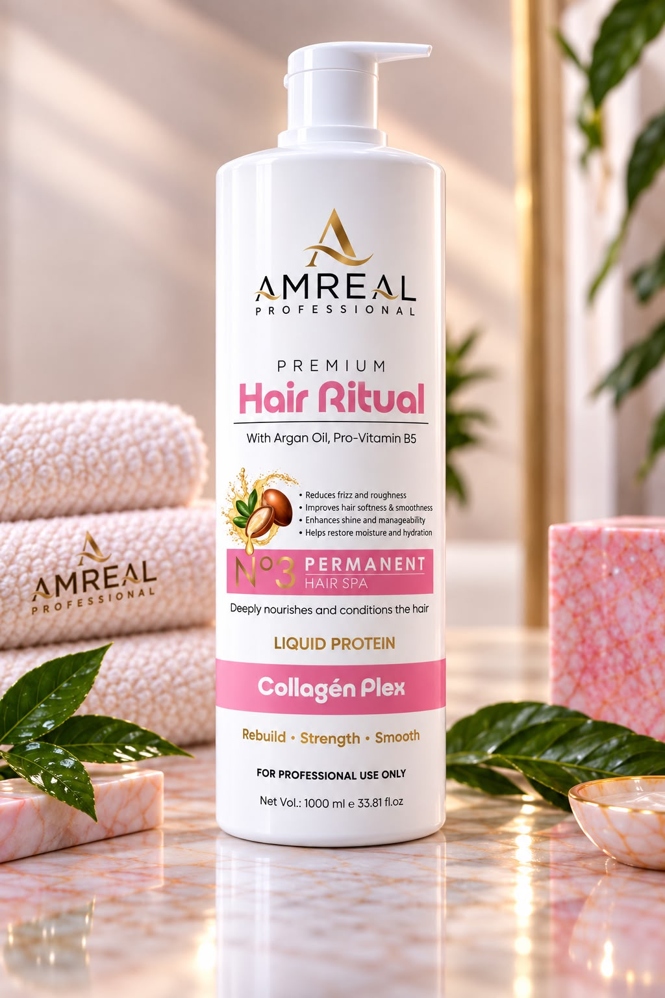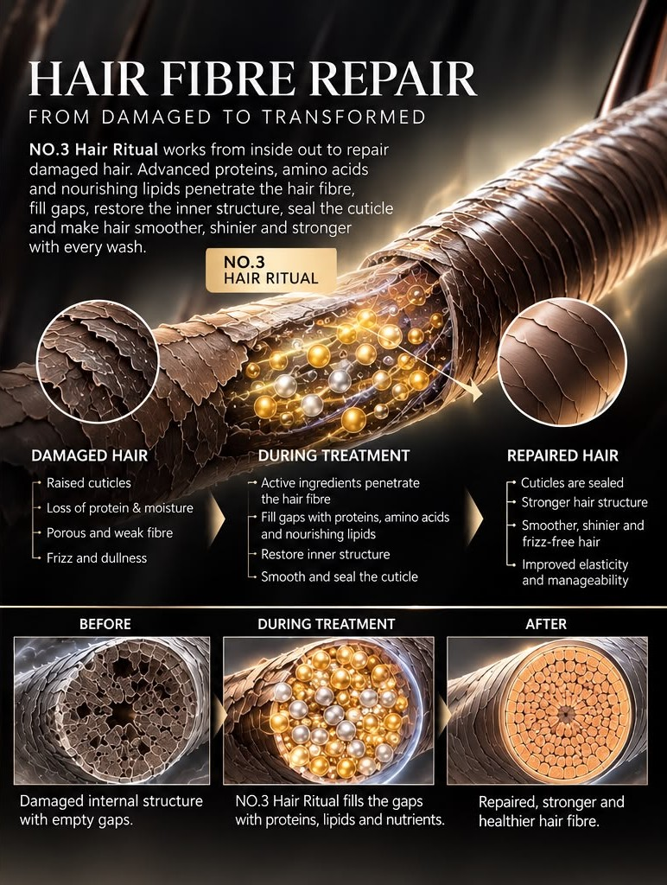PERMANENT HAIR SPA- (our Hero product)- use thre four types of pics for the same product as shown in the website of (https://justhuman.co.in/products/the-sensation-cream-advanced-ai-formulated-oxytocin-skincare)

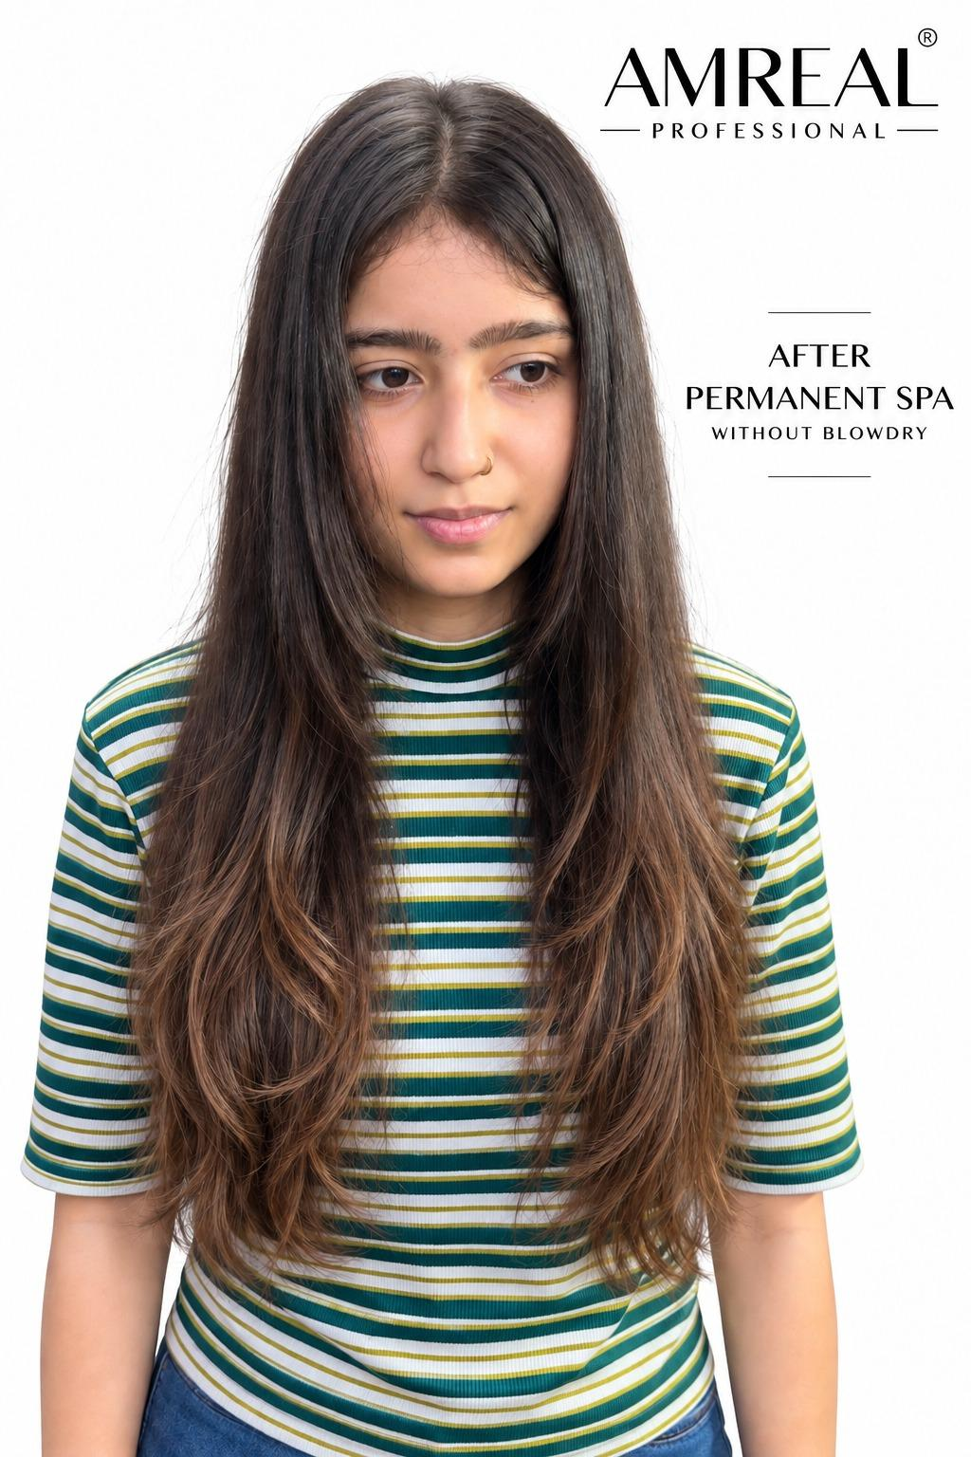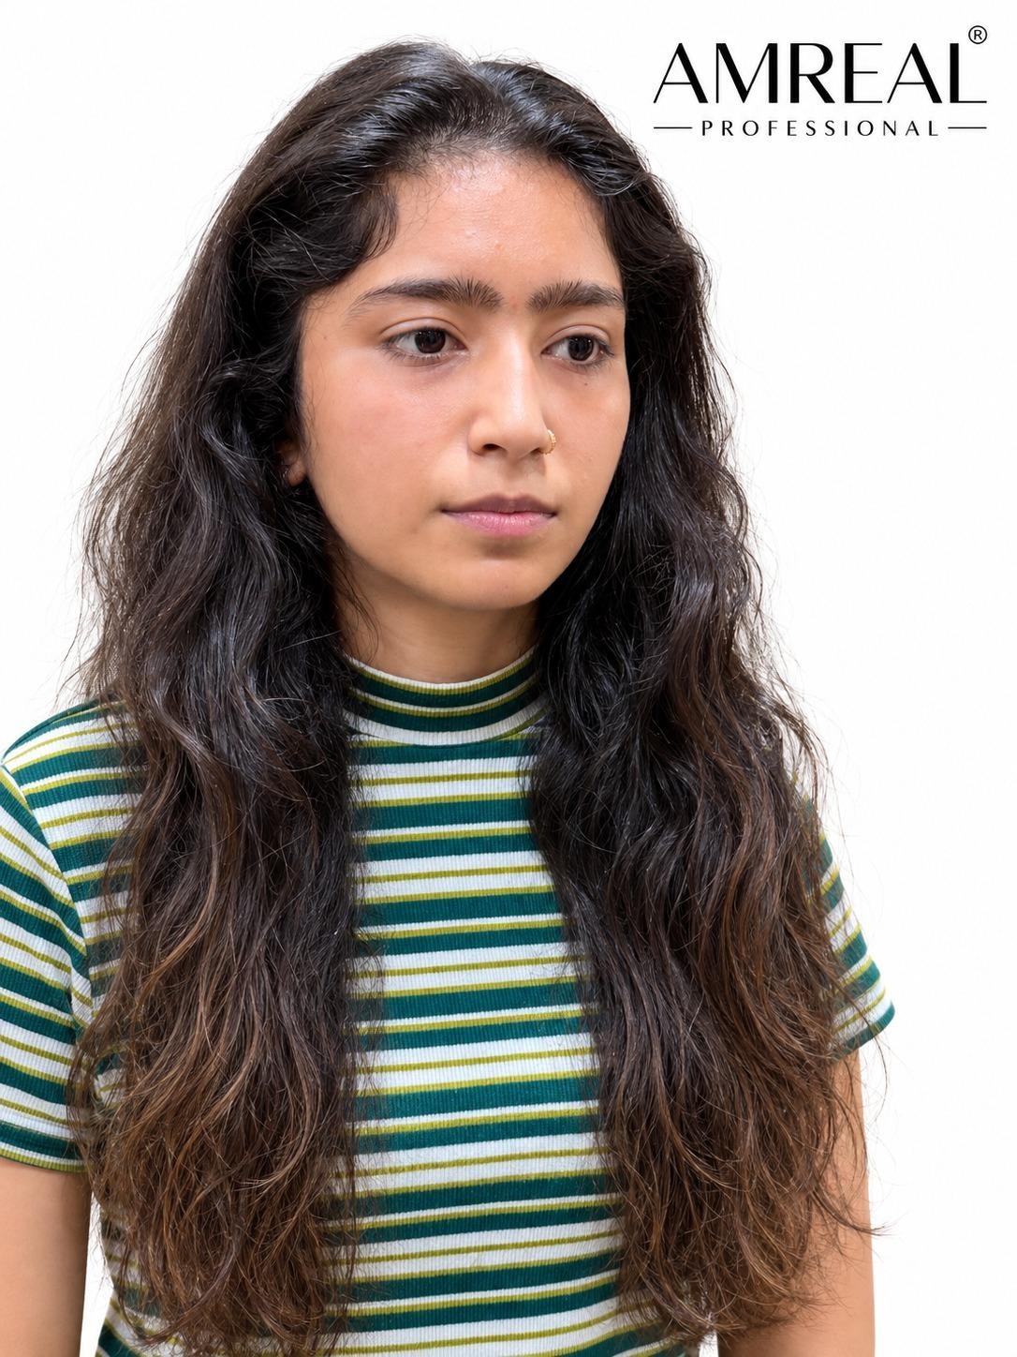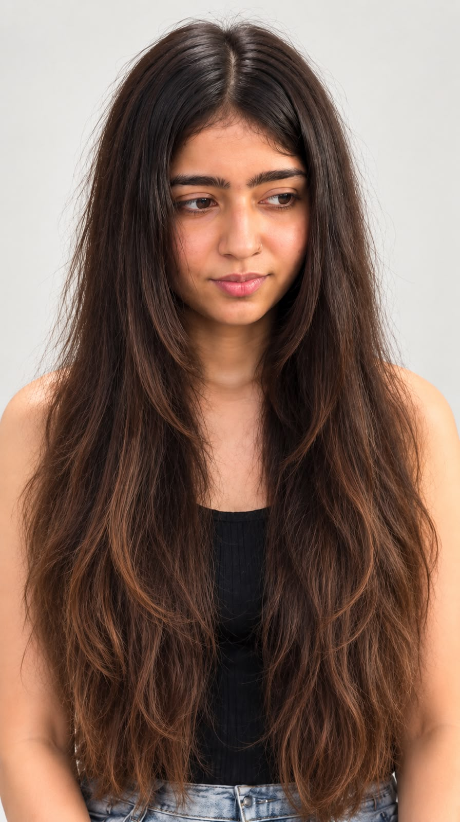
After- Before- 2 months after

in front of permanent hair spa or place you like but we want highlight

MORE THAN A HAIR SPA

3-5 MONTHS OF
SMOOTHER, MORE MANAGEABLE HAIR.
ONE RITUAL. LONG-LASTING RESULTS.

ingredients in front of permanent hair spa pick 2-3 01 — COLLAGEN PROTEINS
Fibre Conditioning

02 — HYDROLYZED KERATIN
Smoothness & Manageability

03 — ARGAN OIL
Nourishment & Shine

04 — PRO-VITAMIN B5
Softness & Conditioning

HAIR TYPES

Suitable for All Hair Types

Personalized according to hair texture, condition & treatment history

Next product - Slik Protein- Understand the label - FYIP

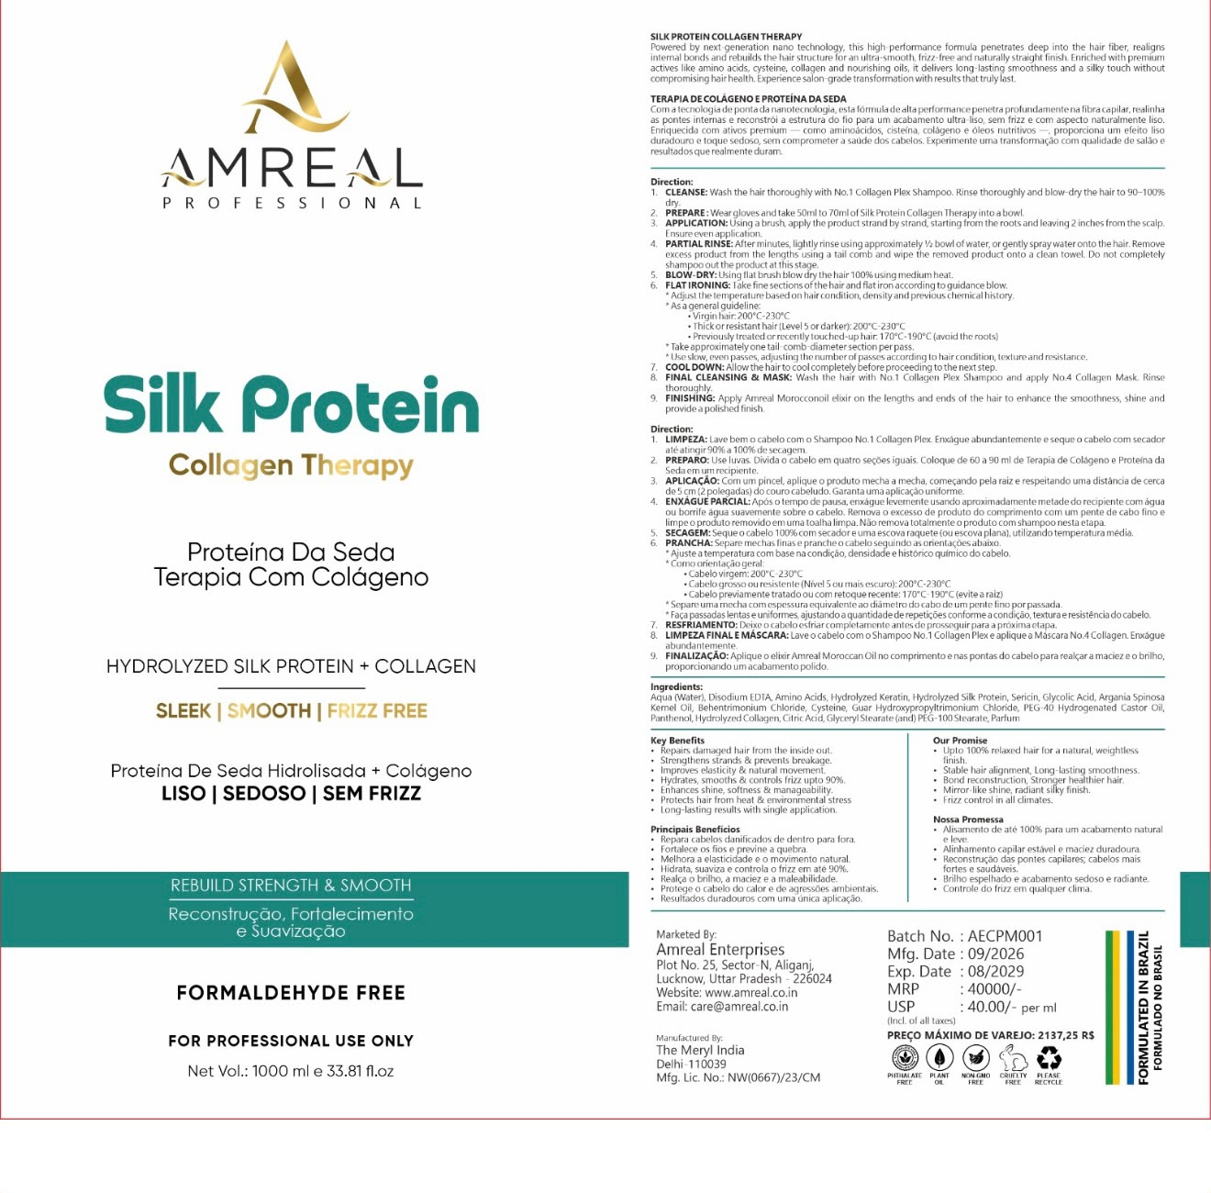
SILK PROTEIN COLLAGEN THERAPY

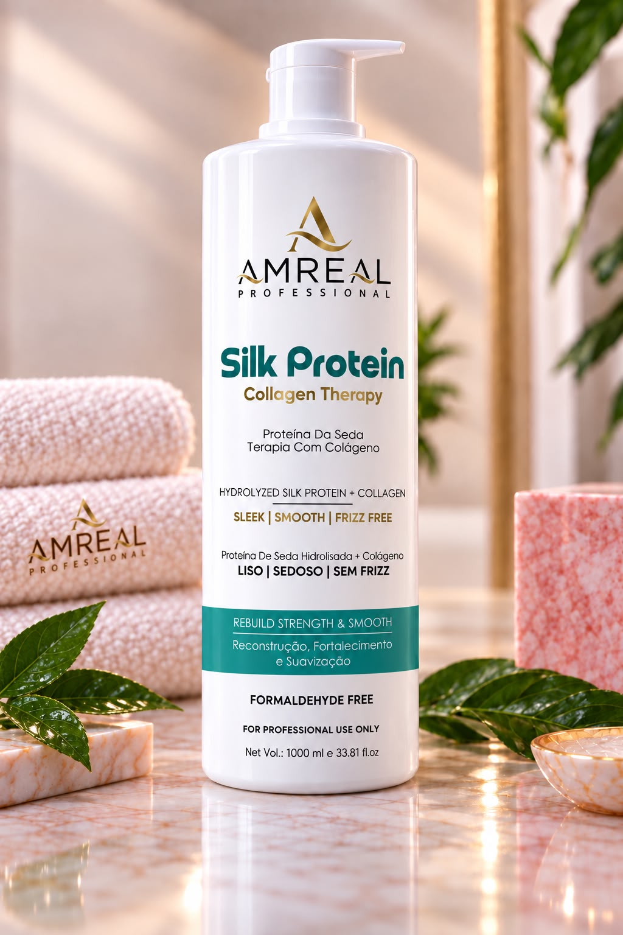

HAIR TYPES

Suitable for:

* Curly Hair
* Wavy Hair
* Frizzy / Unruly Hair
* Coarse Hair
* Dry Hair
* Dull / Rough Hair
* Colored / Dye-Treated Hair
* Henna-Treated Hair

Professional results customized according to hair texture, condition & chemical history. this all will come in short

CONCERNS

FRIZZ & FLYAWAYS
UNMANAGEABLE HAIR
DRYNESS & ROUGHNESS
DULLNESS & LACK OF SHINE
COARSE / UNRULY TEXTURE
WEAKNESS & BREAKAGE

KEY INGREDIENT TECHNOLOGY

HYDROLYZED SILK PROTEIN
Helps improve softness, smoothness and the silky feel of the hair fibre.

HYDROLYZED COLLAGEN
Provides conditioning and fibre-supporting care.

HYDROLYZED KERATIN
Helps improve the feel, strength and manageability of damaged-looking hair.

AMINO ACIDS + CYSTEINE
Support the hair fibre and contribute to a smoother, more manageable finish.

ARGAN OIL
Nourishes the hair and helps enhance softness and shine.

ANTI-HAIRFALL SCALP TONIC

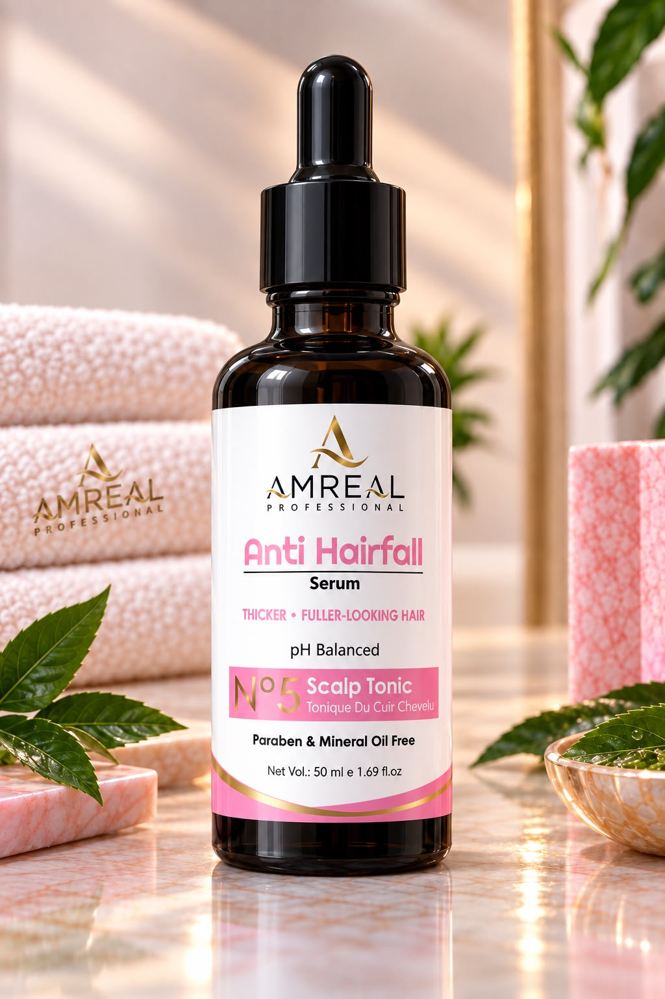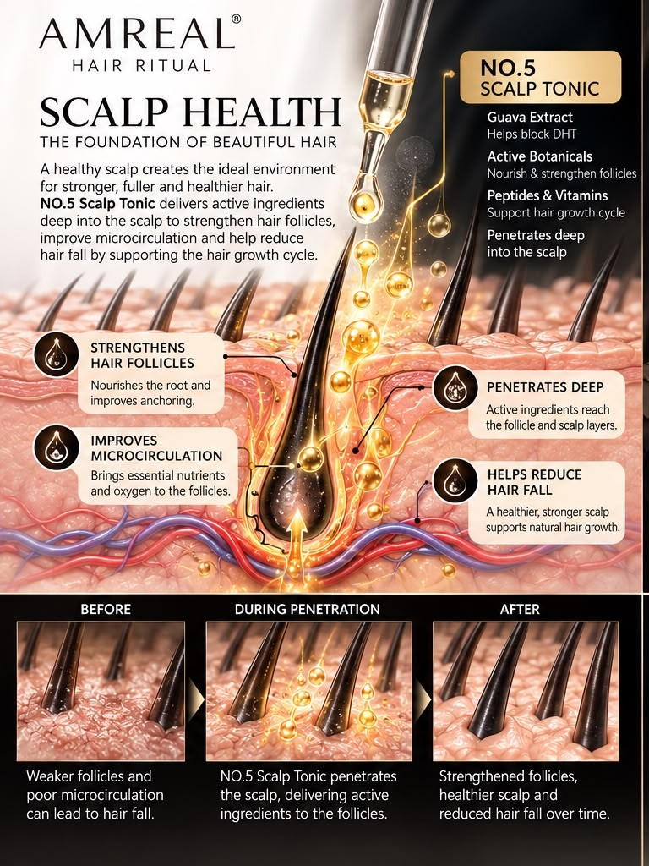

HAIR-FALL CONCERNS

* Excessive Hair Shedding
* Thinning-Looking Hair
* Reduced Hair Density
* Weak / Fragile-Looking Hair
* Loss of Fuller Appearance
* Hair That Looks Less Dense Over Time

KEY BENEFITS

Supports Scalp Vitality
Helps maintain a healthy-looking scalp environment.

Supports Fuller-Looking Hair
Designed to help maintain the appearance of thicker, fuller, stronger-looking hair.

Scalp & DHT-Pathway Support
Formulated for targeted scalp care around DHT-pathway-related concerns.

Lightweight Leave-On Care
A lightweight scalp tonic designed for regular use without a heavy, oily feel.

Daily Scalp Support
Suitable as part of a consistent scalp-care routine

WHO SHOULD USE IT?

Ideal for people experiencing:

Hair Shedding • Thinning-Looking Hair • Reduced Density • Weak-Looking Hair •

SUITABLE FOR

Normal • Oily • Dry • Combination Scalp

ACTIVE TECHNOLOGY

3% Redensyl
4% Anagain
B2 Complex
Caffeine
Niacinamide
Biotin
Guava Leaf Extract

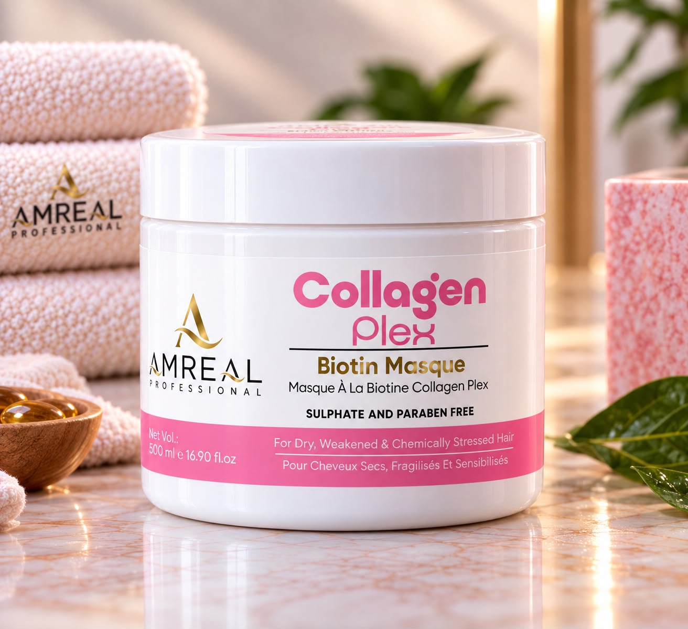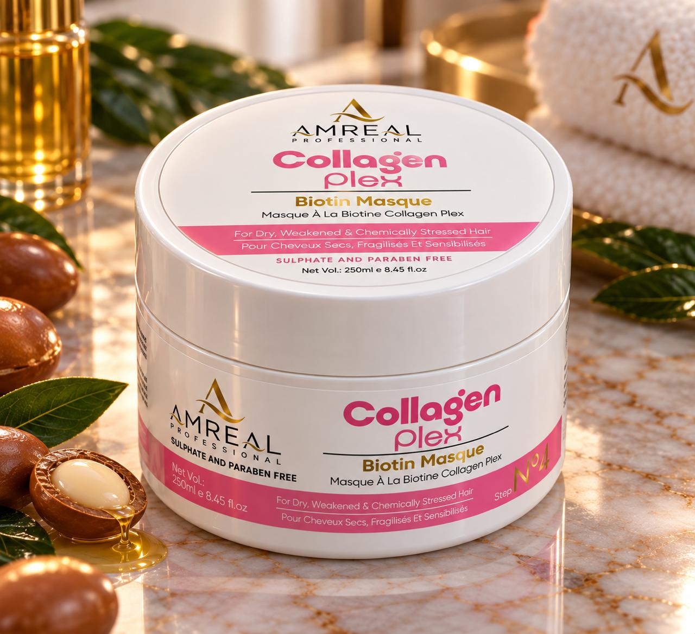

Big and Small- 500 and 250 ml

AMREAL COLLAGEN PLEX BIOTIN MASQUE — NO.4

CONCERNS

* Dryness
* Weakness
* Hair Breakage
* Chemically Stressed Hair
* Roughness
* Loss of Softness
* Loss of Shine
* Damaged-Looking Hair
* Unmanageable Hair

KEY BENEFITS

* Replenishes dry and weakened hair
* Strengthens the hair fibre
* Smoothens rough, stressed hair
* Helps improve softness & manageability
* Helps enhance shine
* Provides conditioning and nourishment
* Helps support hair after chemical treatments
* Helps improve the feel of damaged-looking hair

SUITABLE FOR

Dry • Weak • Damaged • Chemically Treated • Colored • Frizzy • Rough Hair

Especially suitable for hair requiring intensive conditioning, replenishment and fibre care

